68. Communities - 11 July 2022

Today we will learn:

1. Community
2. How to Create a Community
3. Search a record
4. How to add Logo and Header in the Community
5. How to use LWC / Aura Component in Community
6. How to create a Tab
7. Add Company Logo in Login Page
8. How to add company logo in Salesforce Login Page

Community Types:

1] Customer Community

2] Partner Community

3] Employee Community

1] Community

A community is a web space (Salesforce Website) through which external users interact with the Salesforce.

OR

Salesforce Communities or Salesforce Experience are **brand spaces designed specifically for Salesforce customers to connect with the community outside their org** (i.e., employees, partners, and customers) and collaborate with them using relevant data and content.

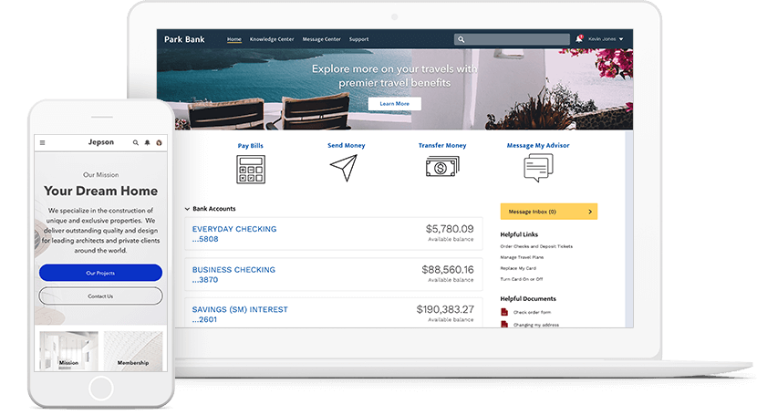

Why to Use Community:

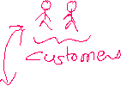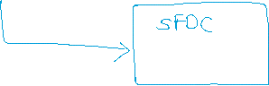

SFDC 1 User 🡺 License (Salesforce) = USD 25 / User / Month = 1800 (22,500)

Agent 1 User = 22500

Nagpur => 1000

Maharashtra = 20000

India = 500000

**LIC Agent 5L = 5L * 22500 = 11,25,00,00,000**

LIC Agent 5L (Community License)

LIC Company 1 Salesforce License = (22,500) 🡺 5L Community License (5L)

1. ac Invest

2] How to Create a Community

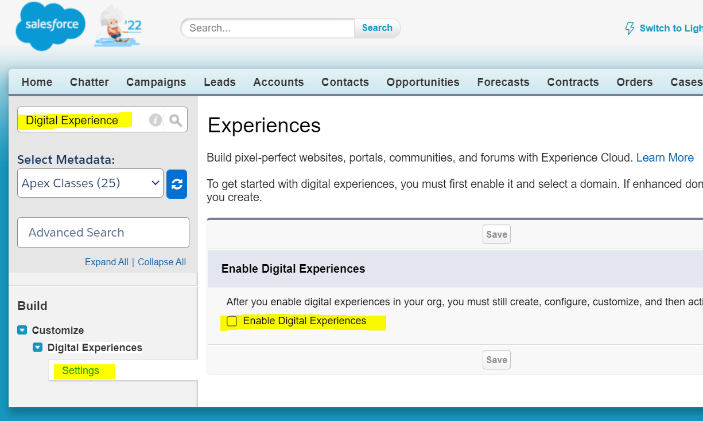

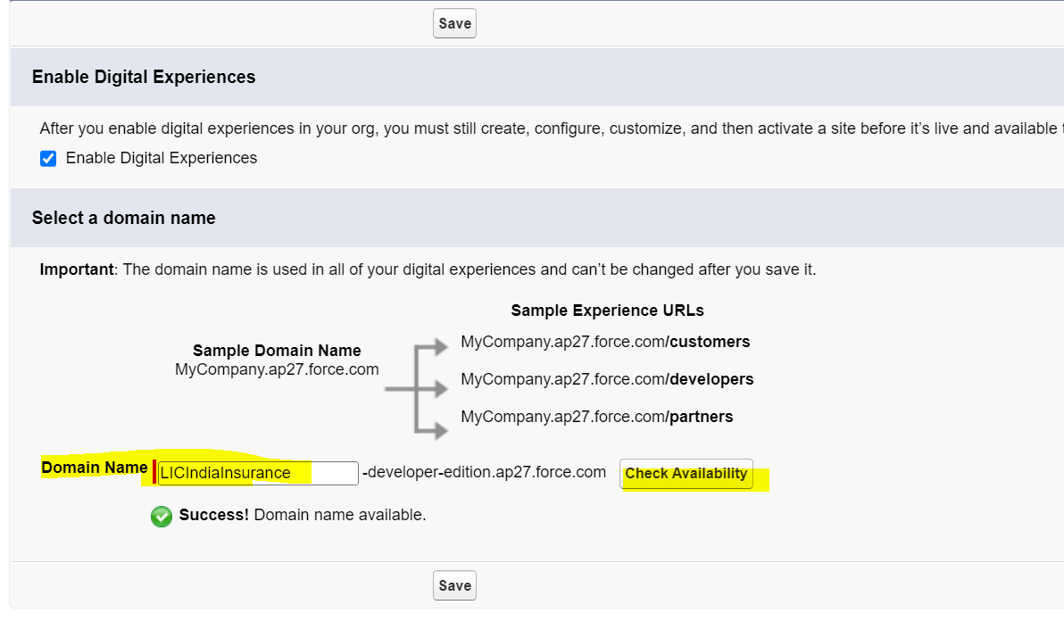

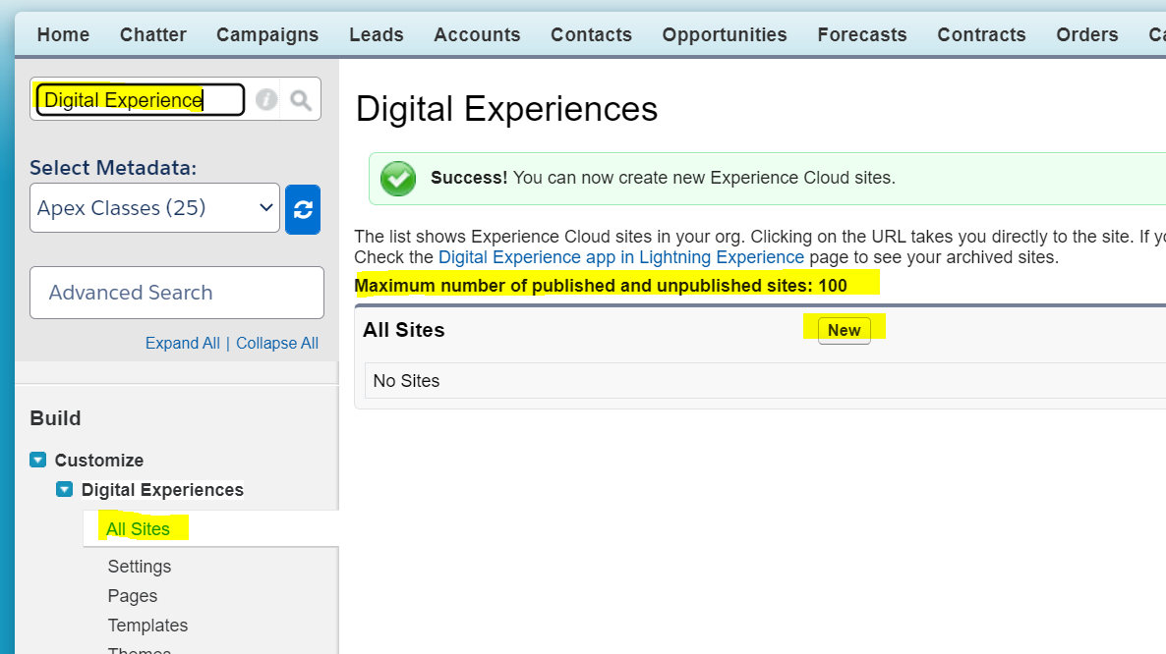

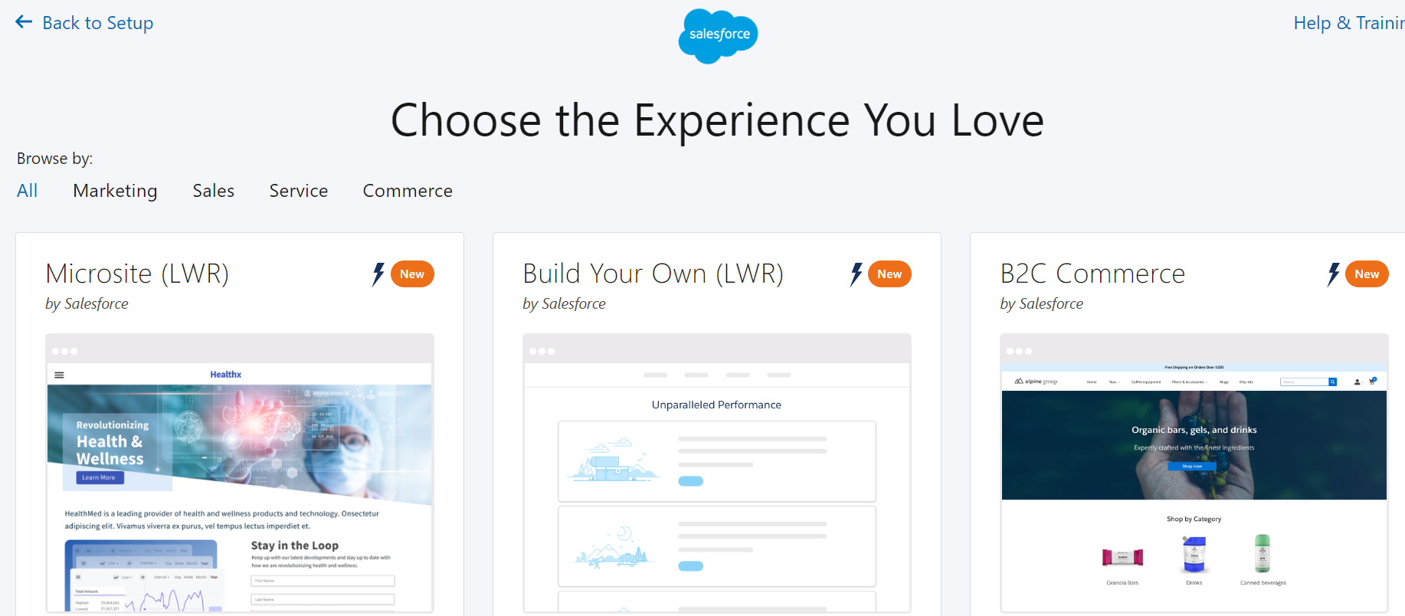

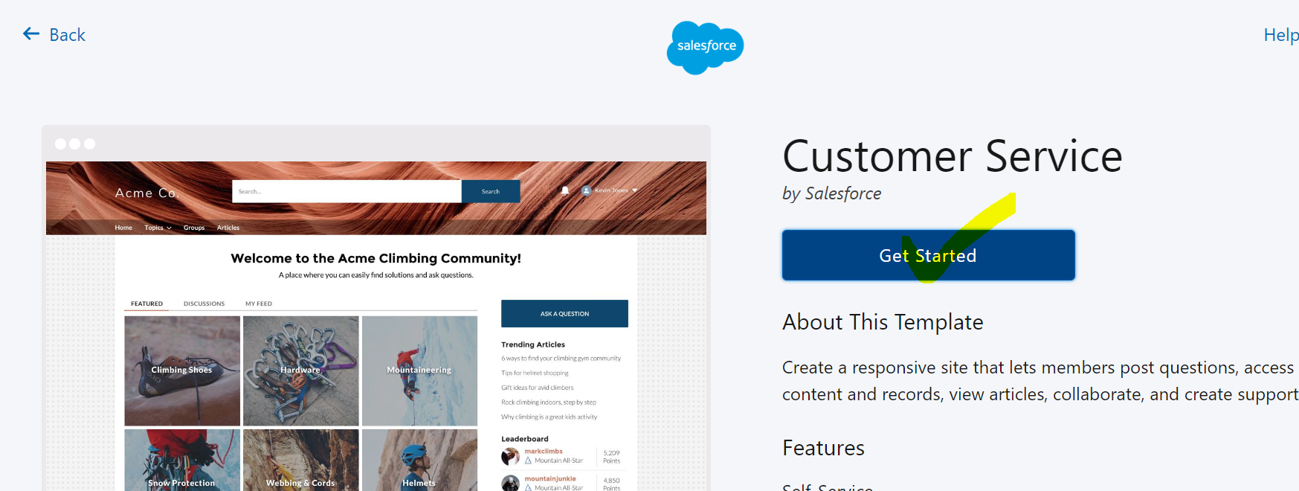

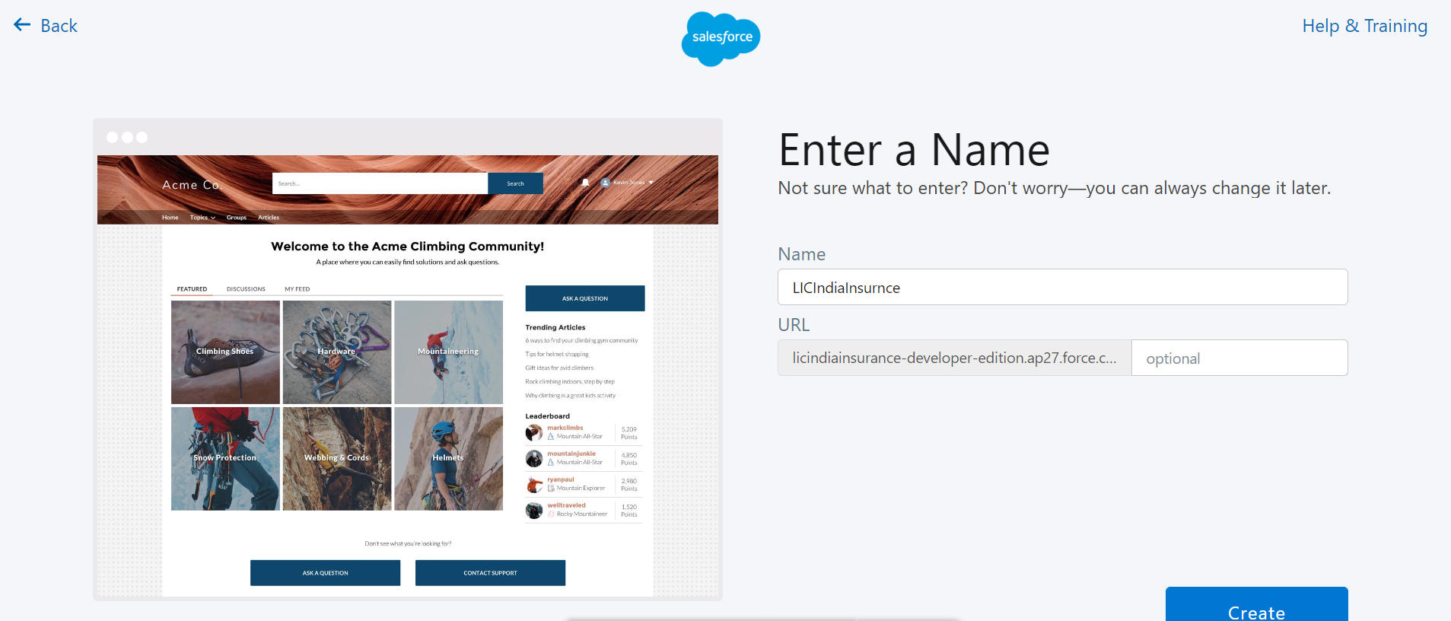

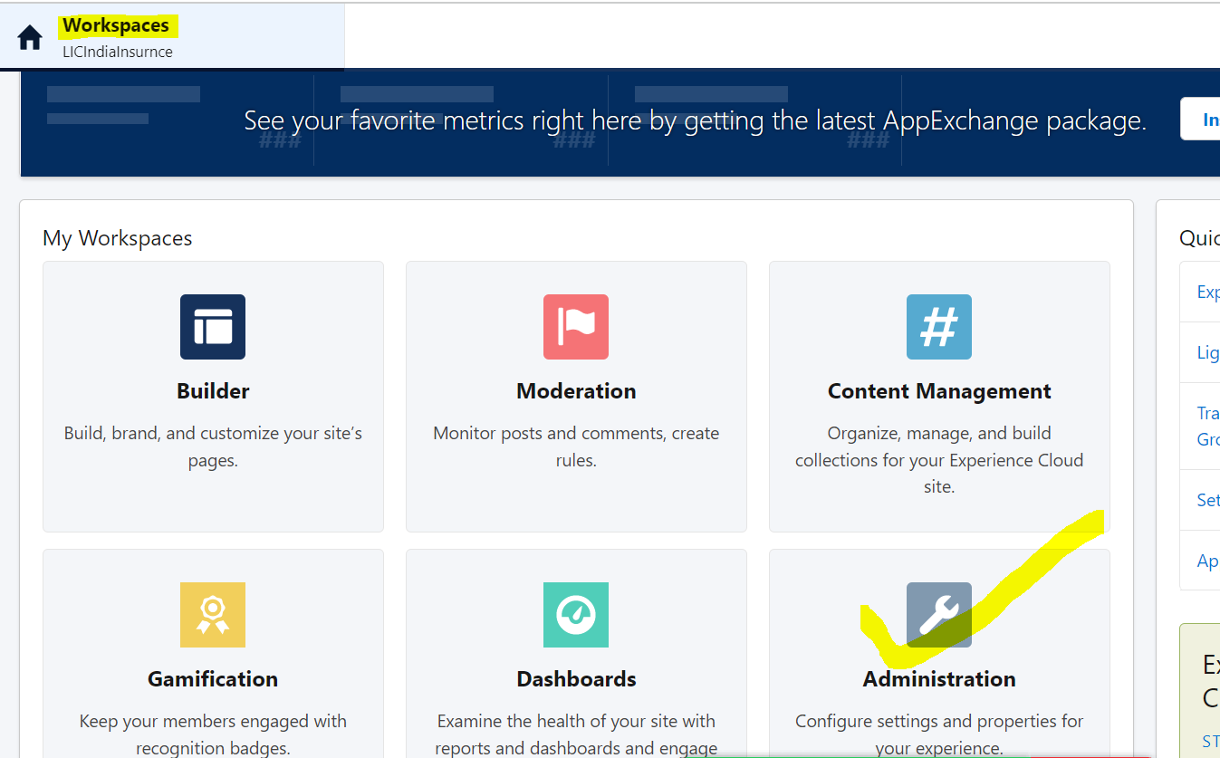

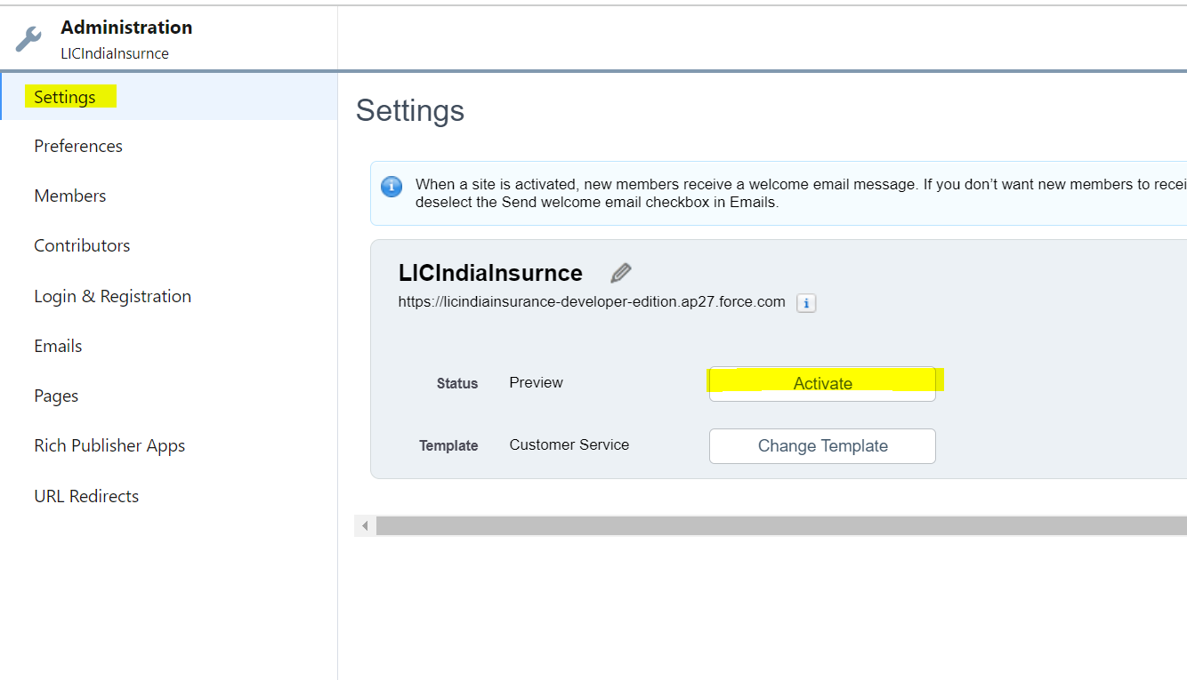

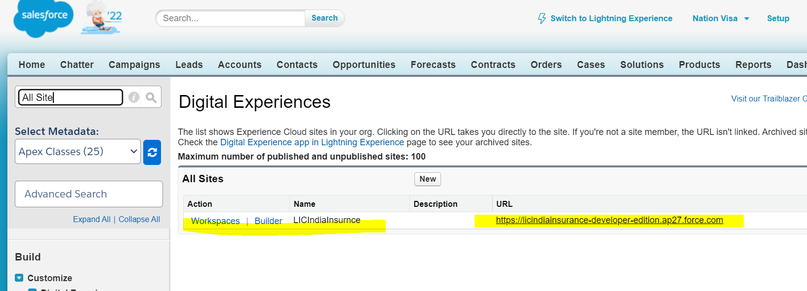

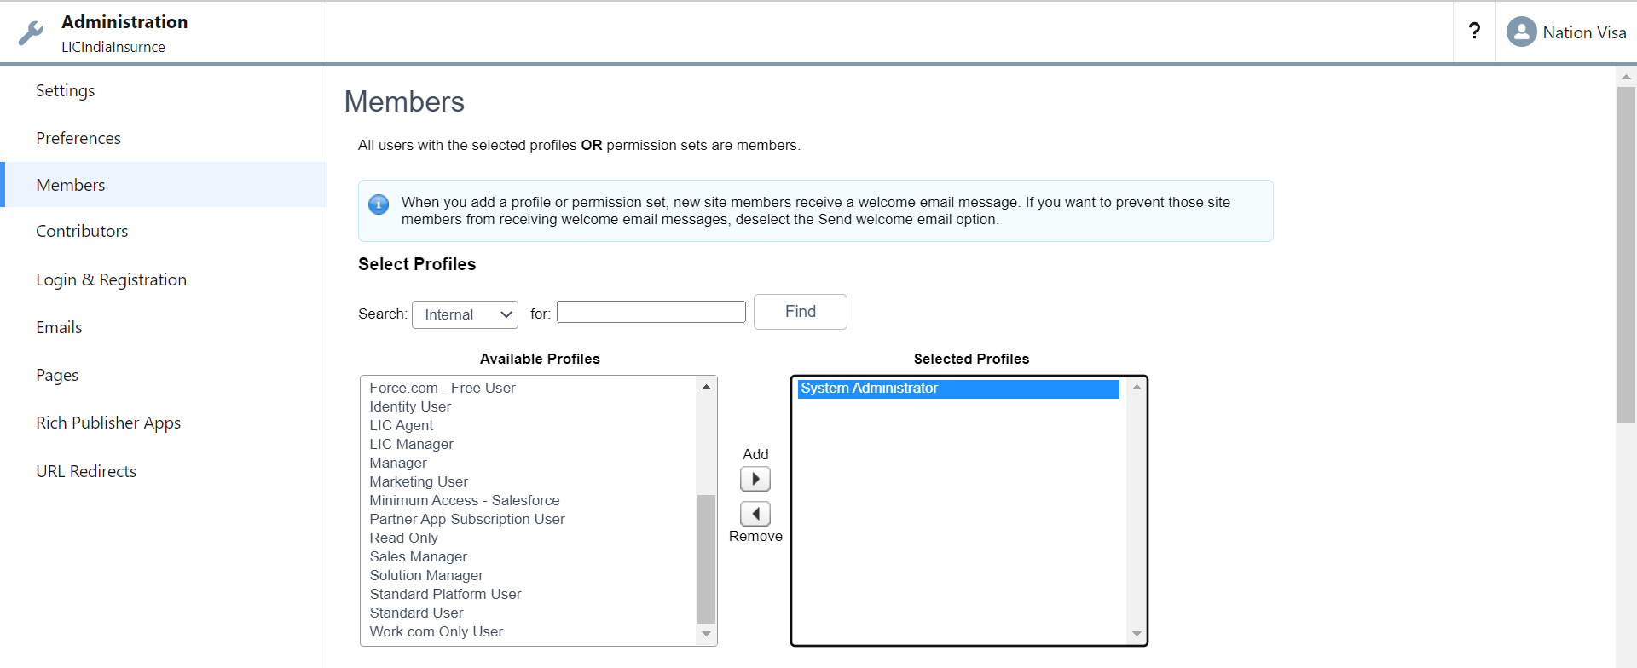

NOW Publish the Community

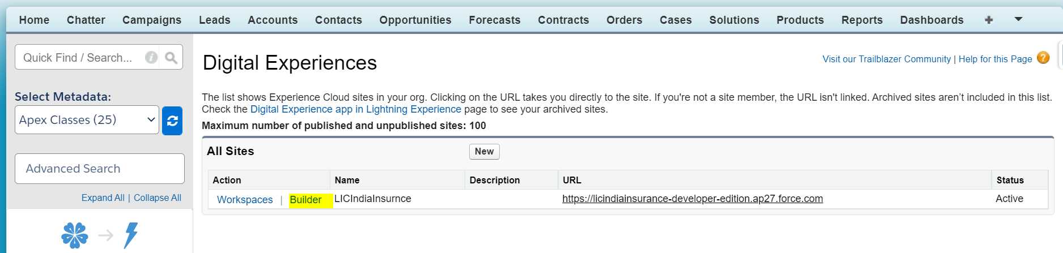

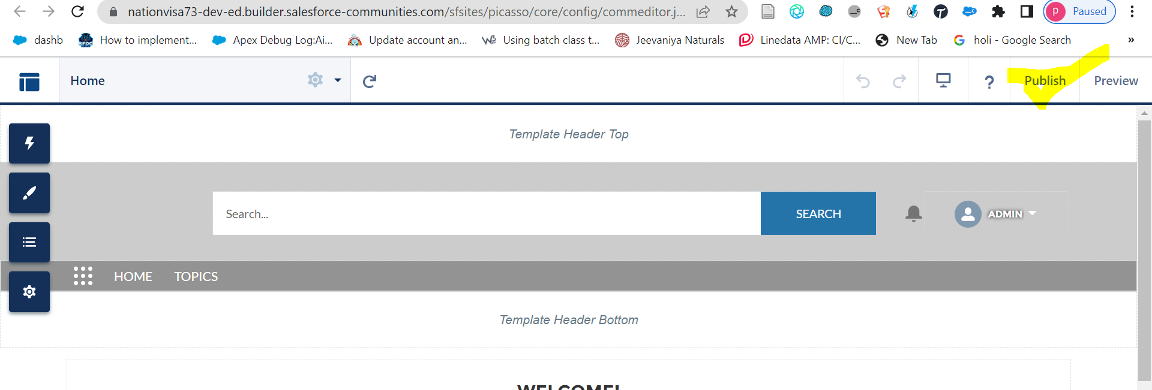

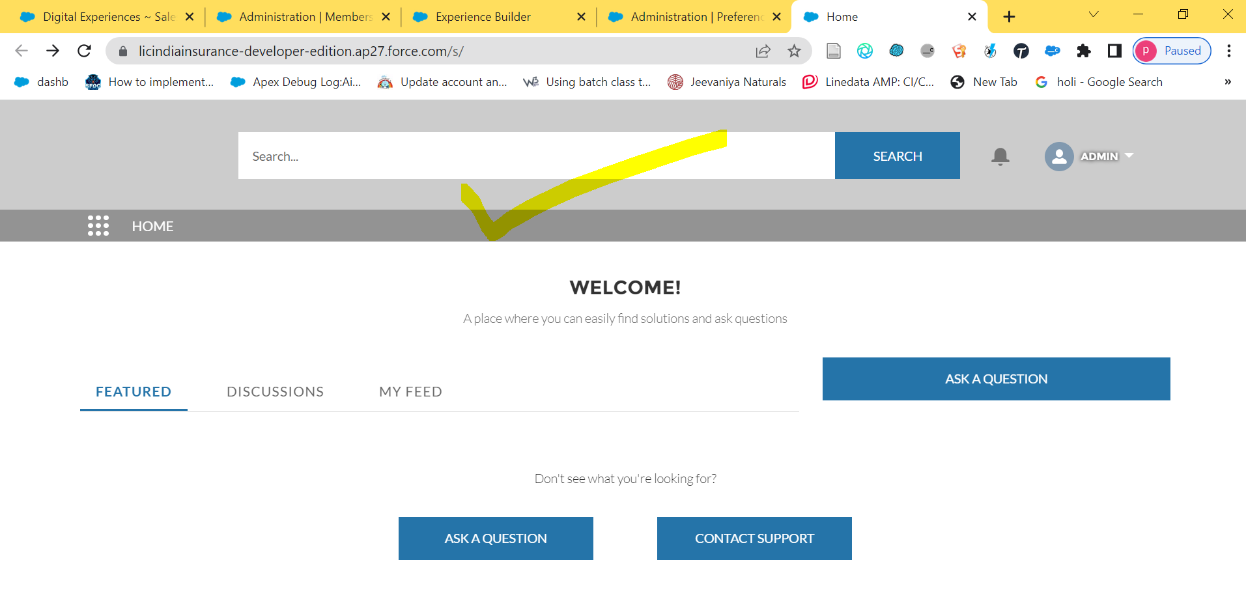

3] Search a record

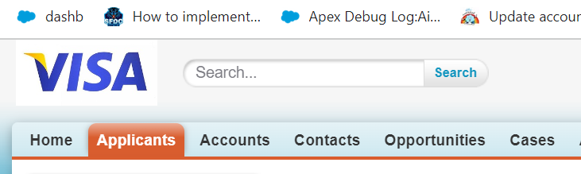



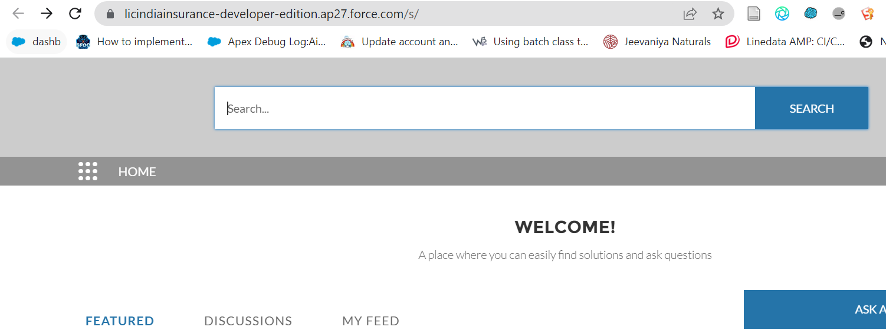

Settings:

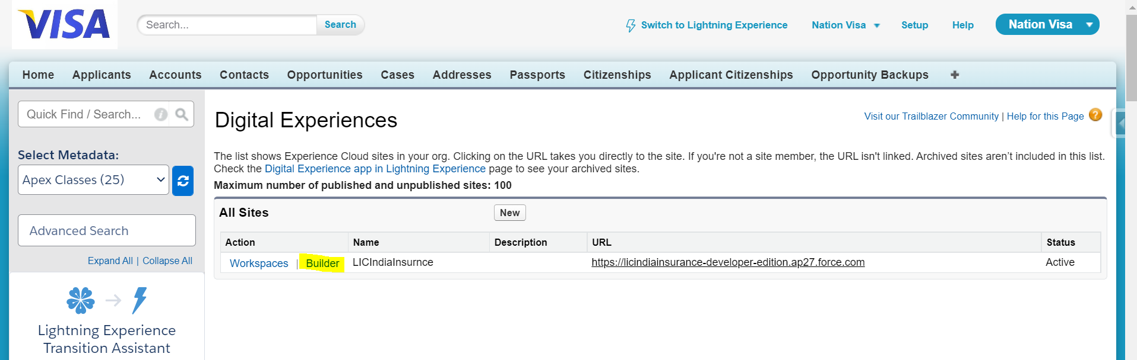

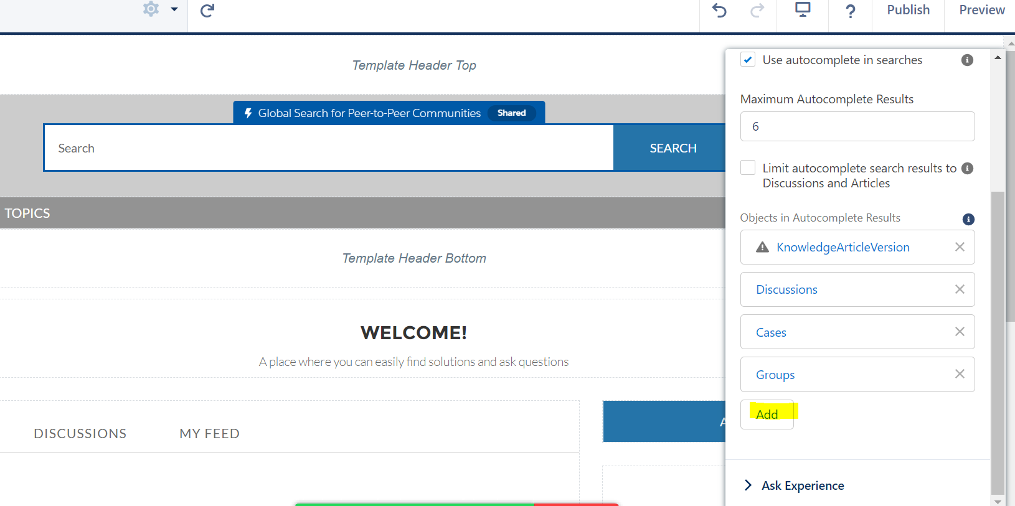

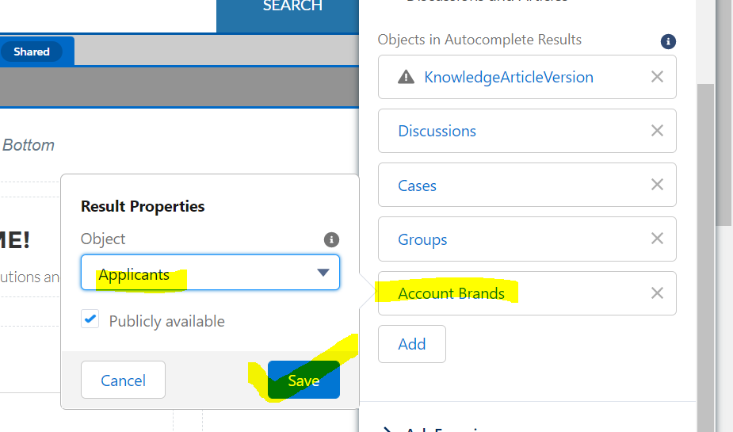

Extra Knowledge:

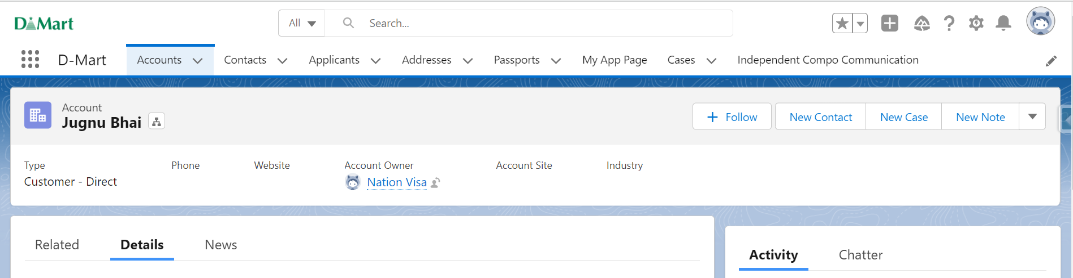



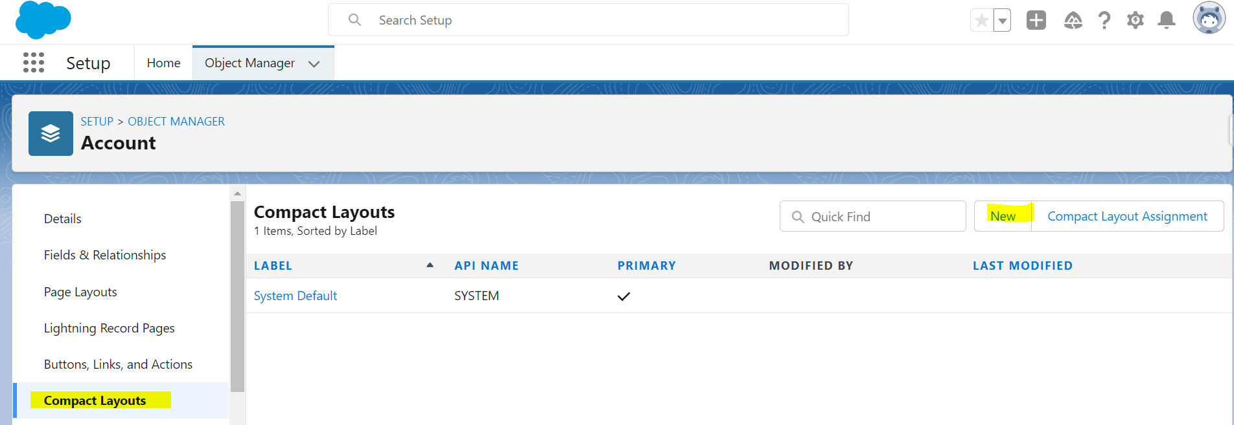

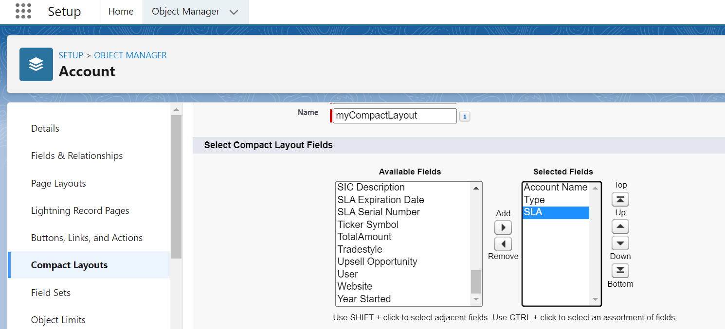

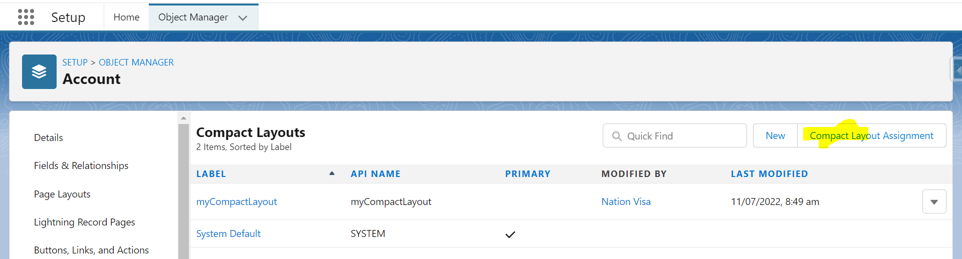

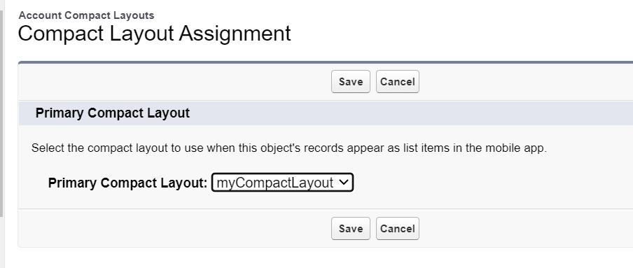

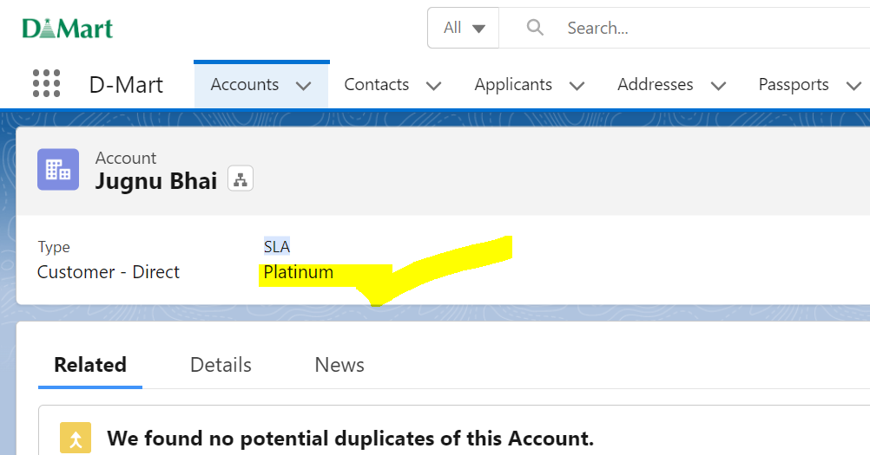

4] How to add Logo and Header in the Community

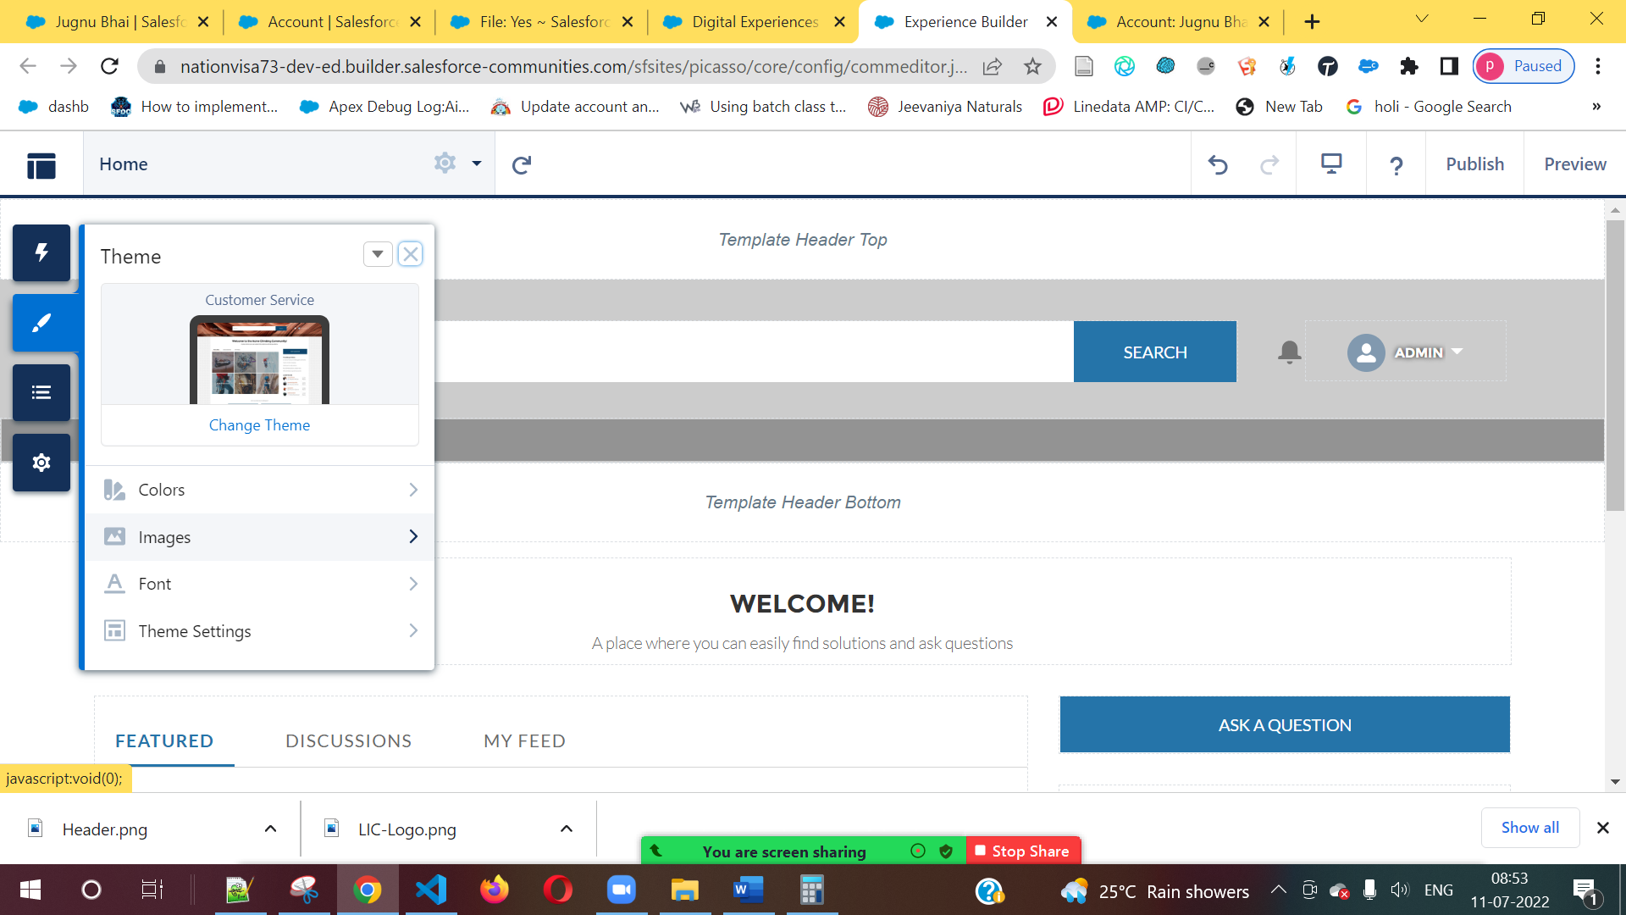

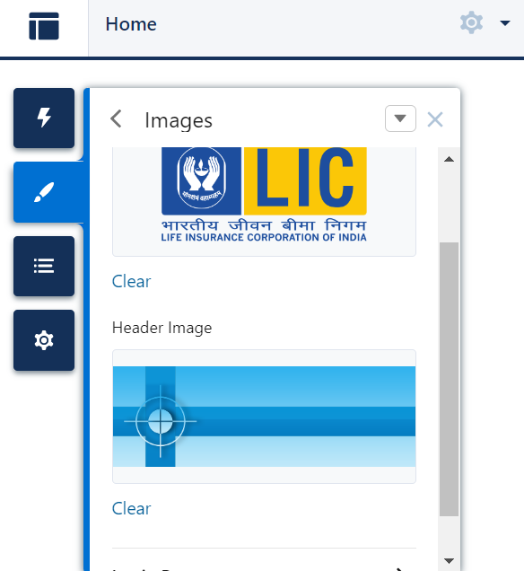

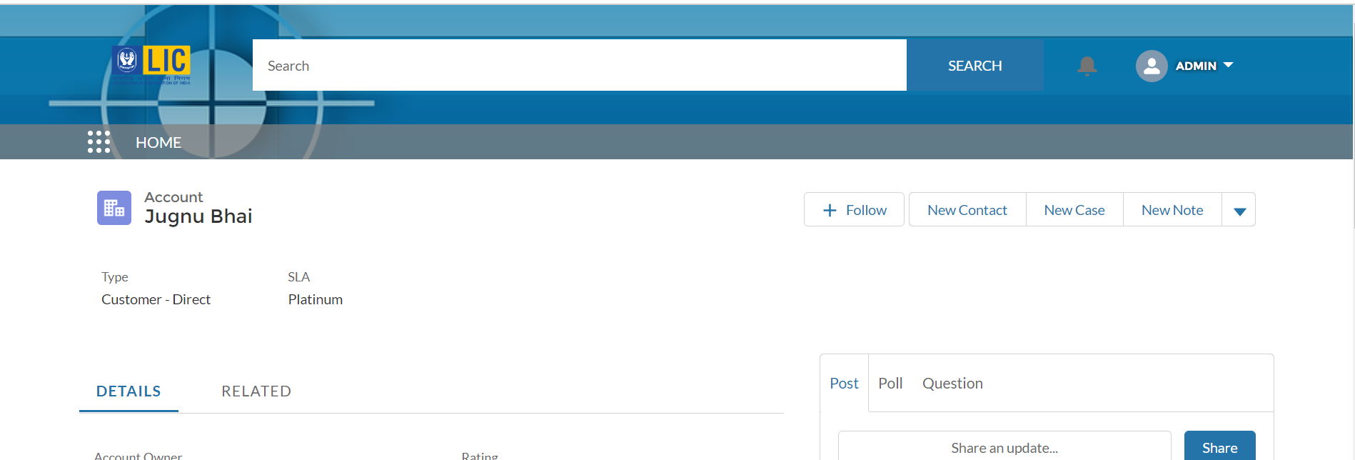

5] How to use LWC / Aura Component in Community

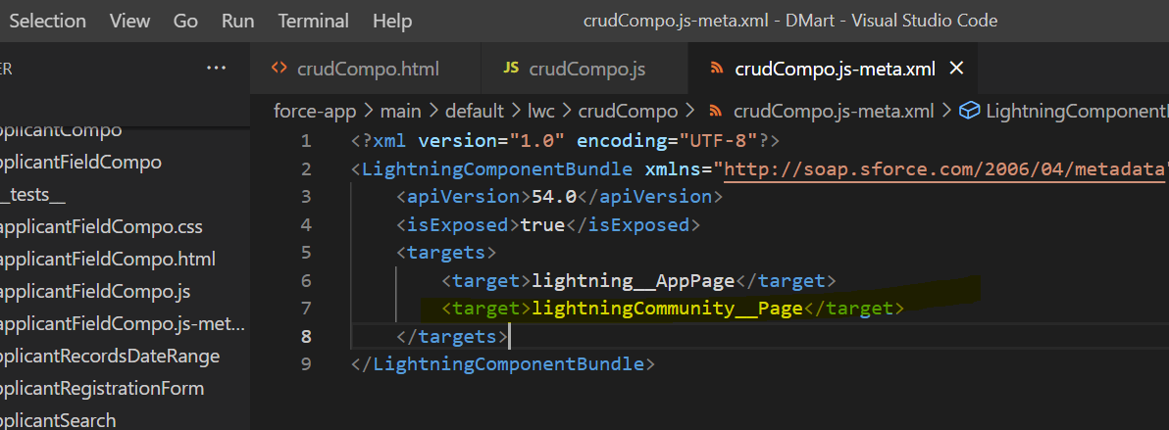

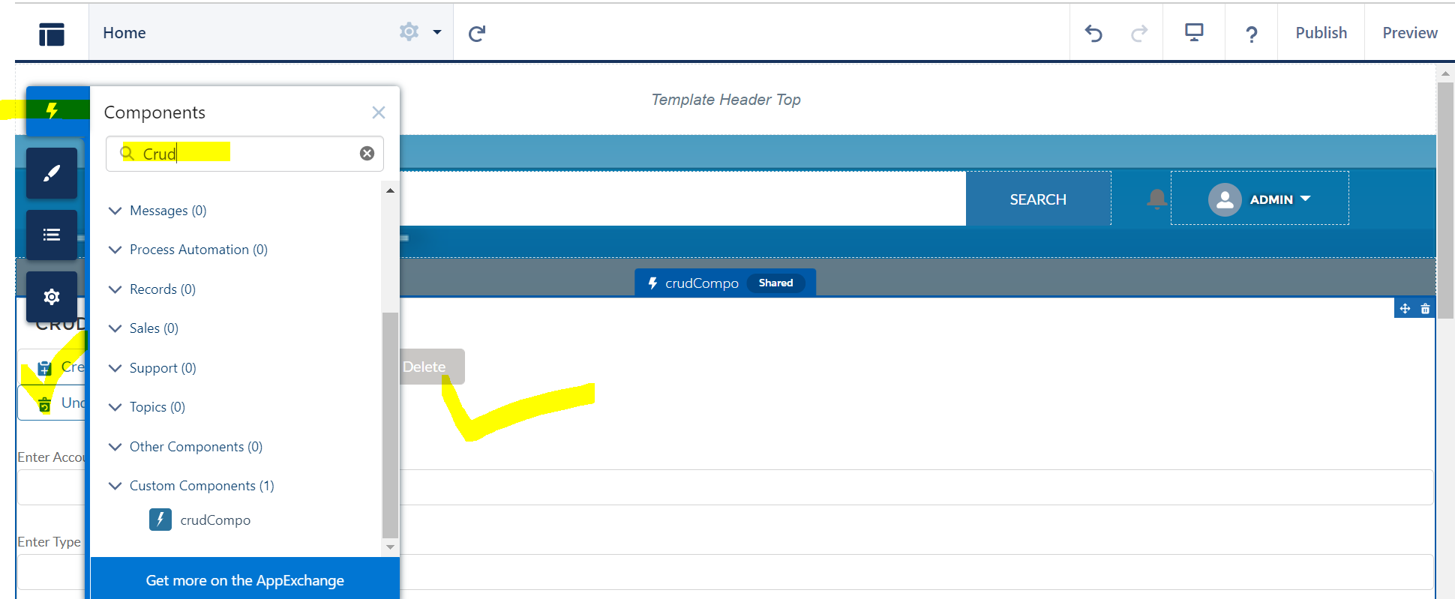

6] How to create a Tab

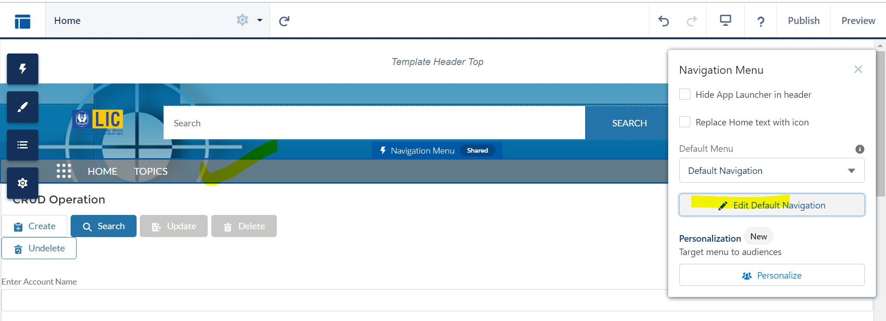

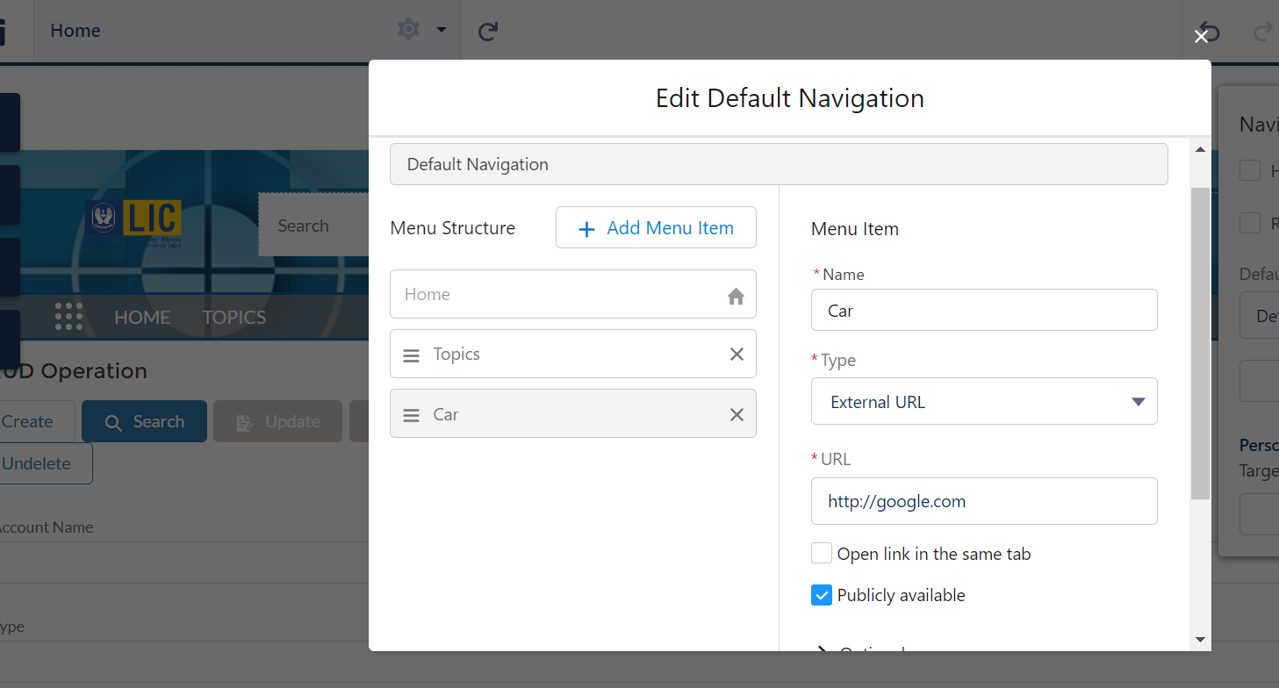

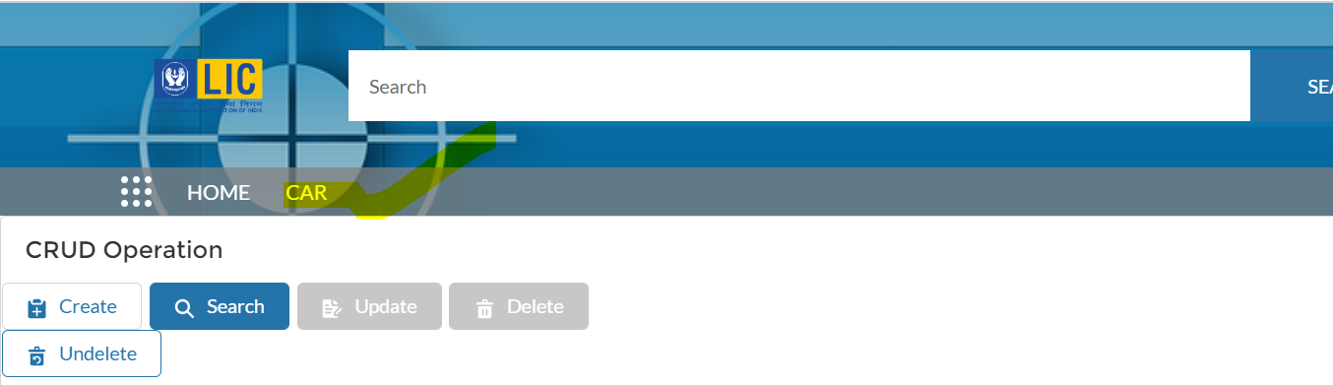

7] Add Company Logo in Login Page

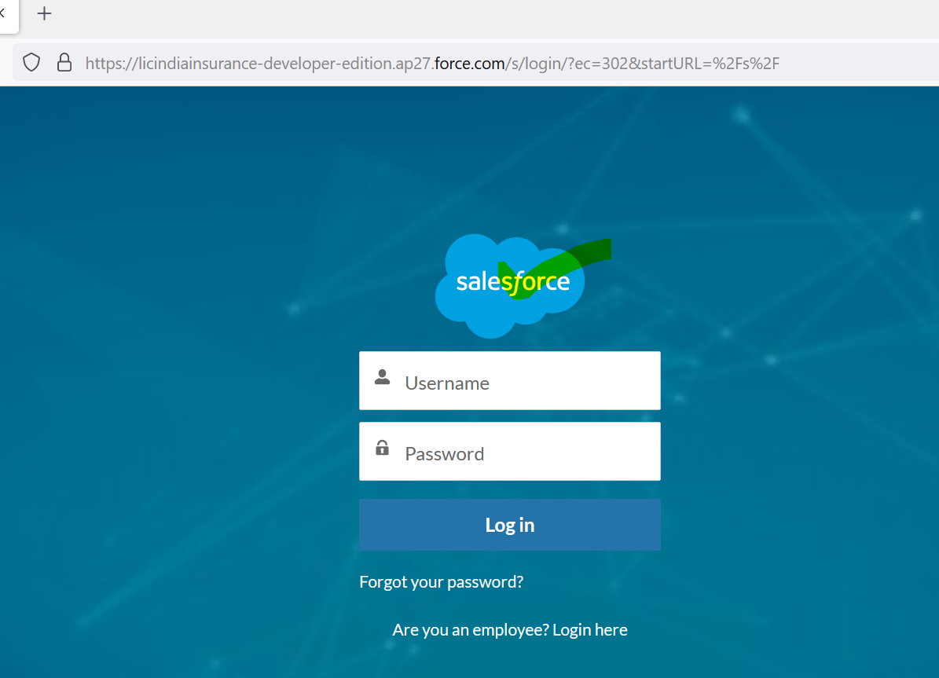

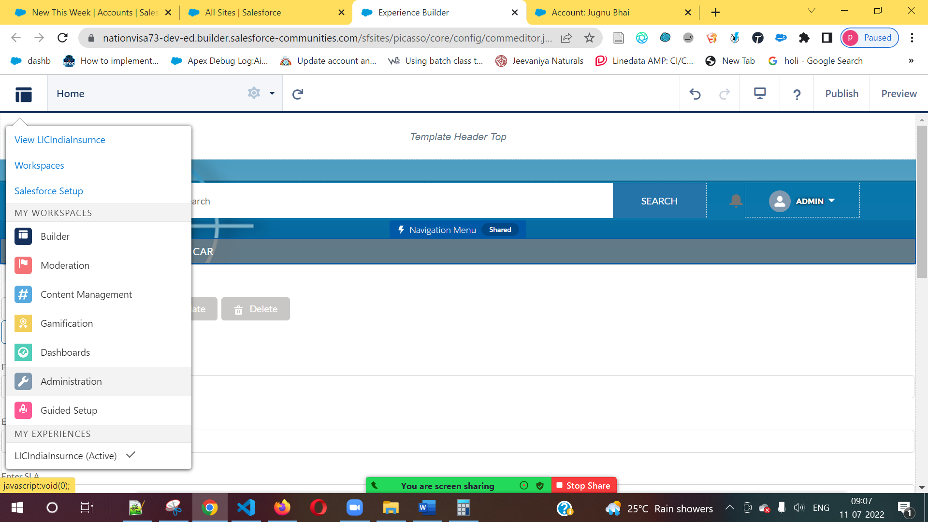

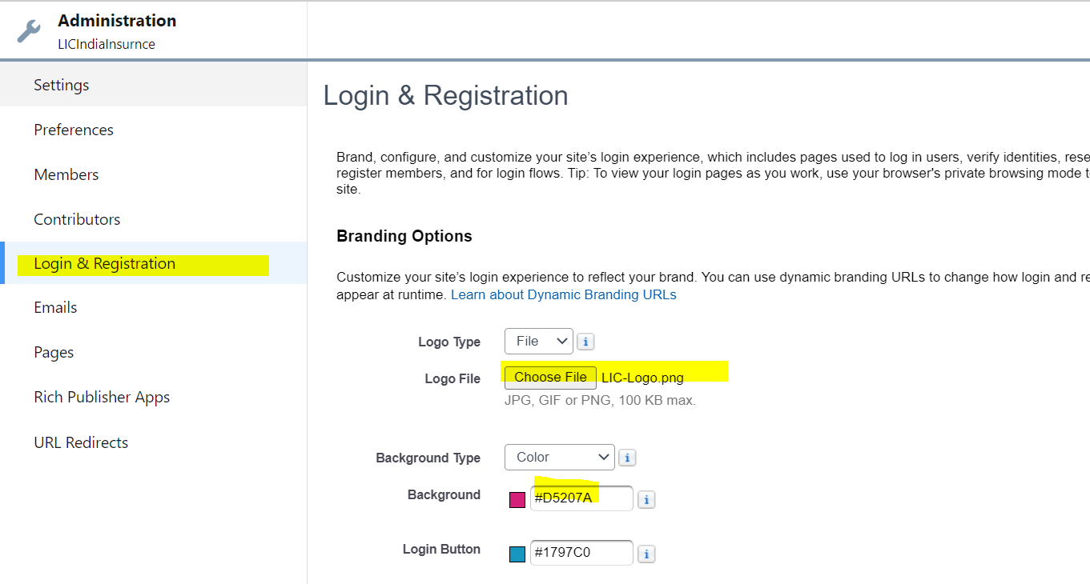

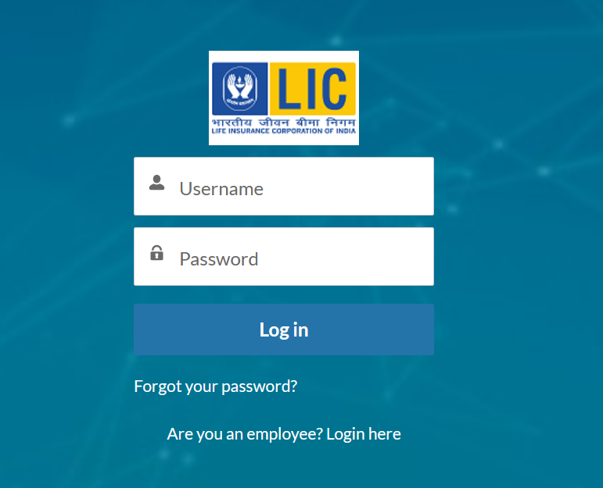

8] How to add company logo in Salesforce Login Page

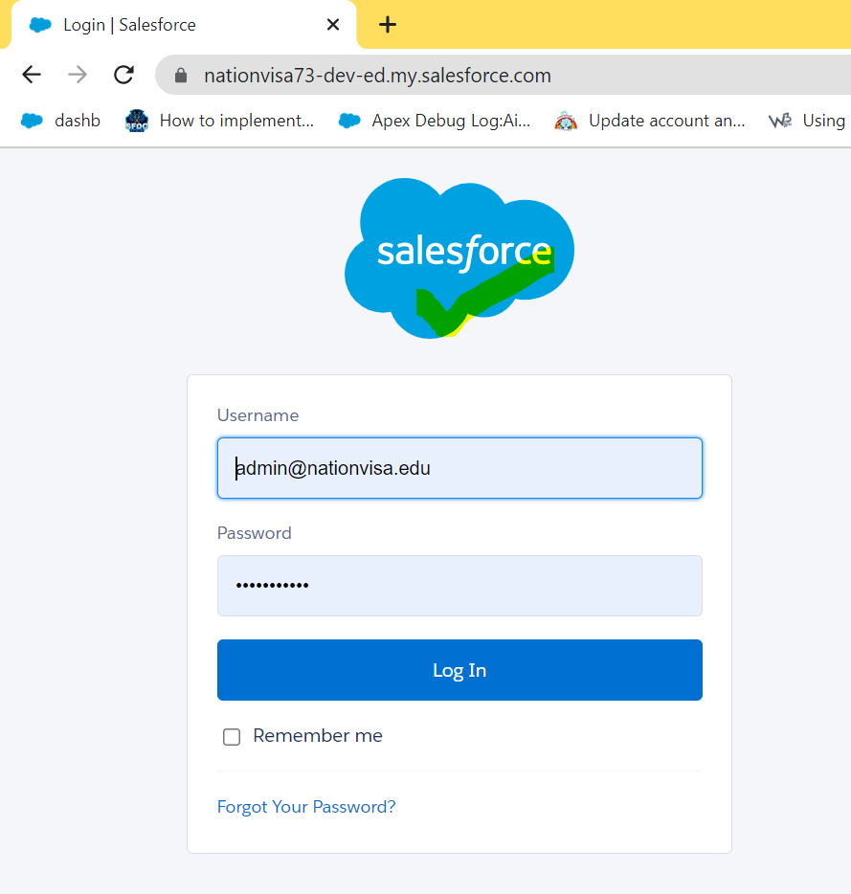

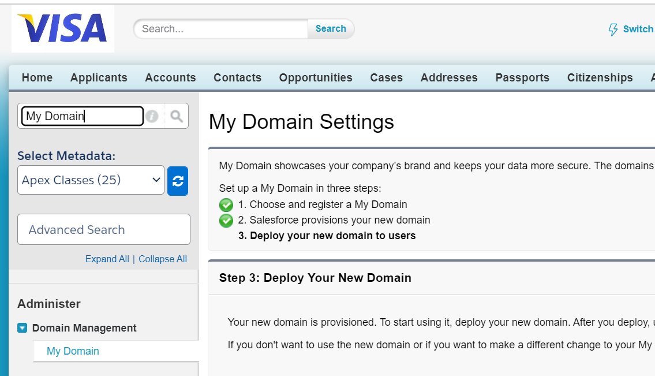

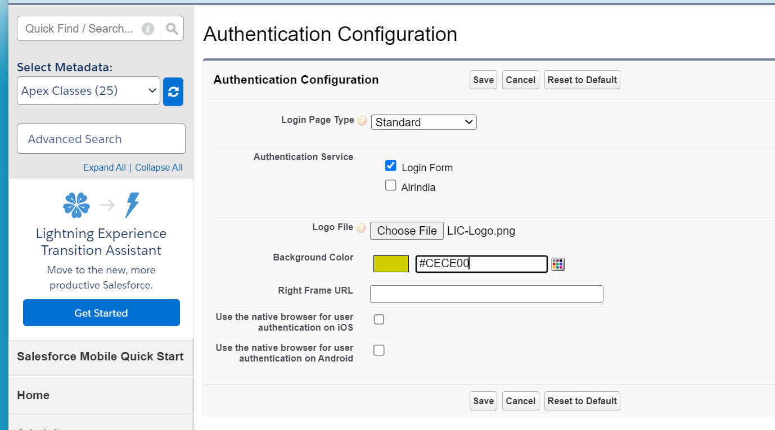

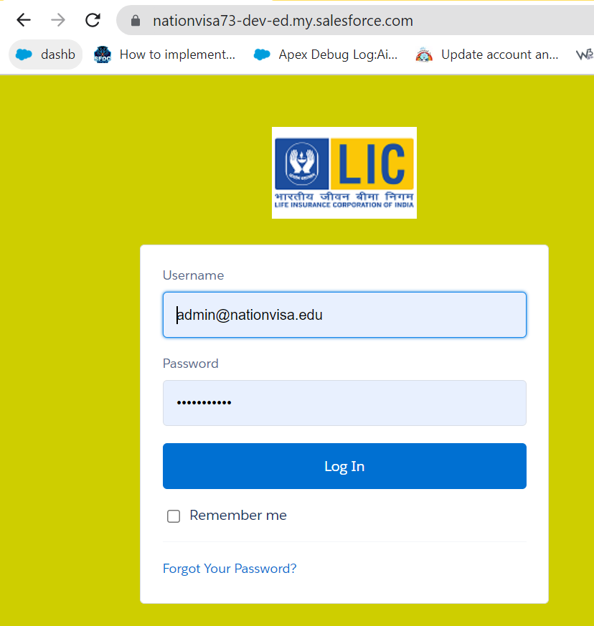

https://nationvisa73-dev-ed.my.salesforce.com/

================END====================